1)USE CASE DIAGRAM:
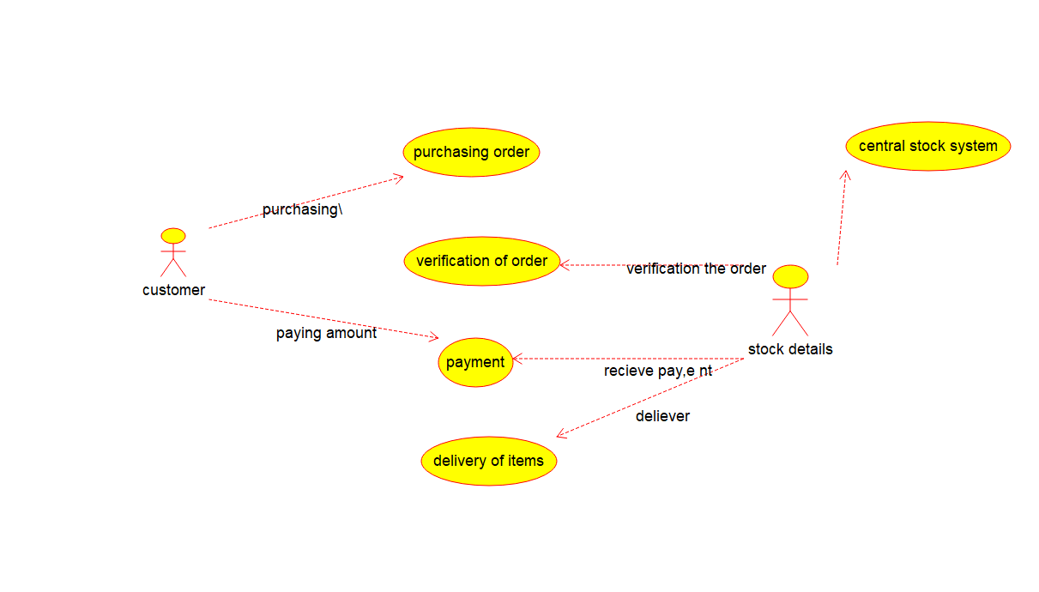
2)CLASS DIAGRAM:
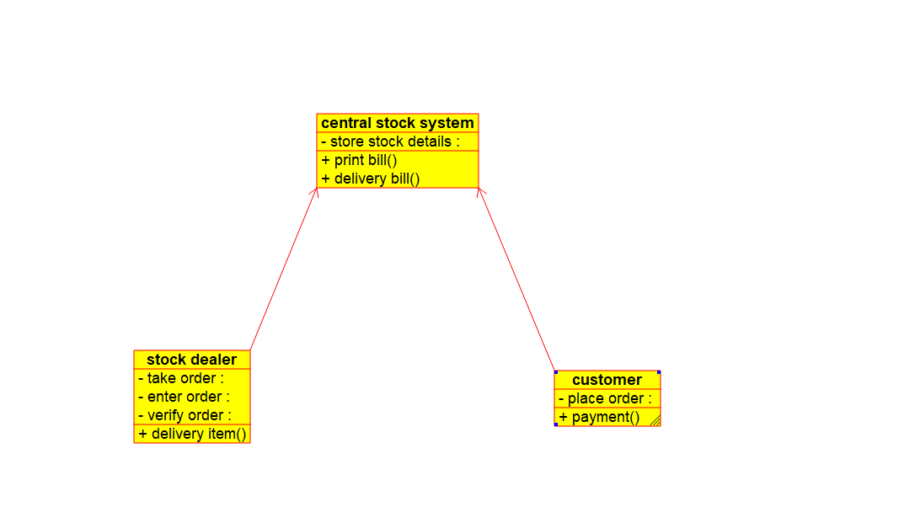

3)SEQUENCE DIAGRAM:
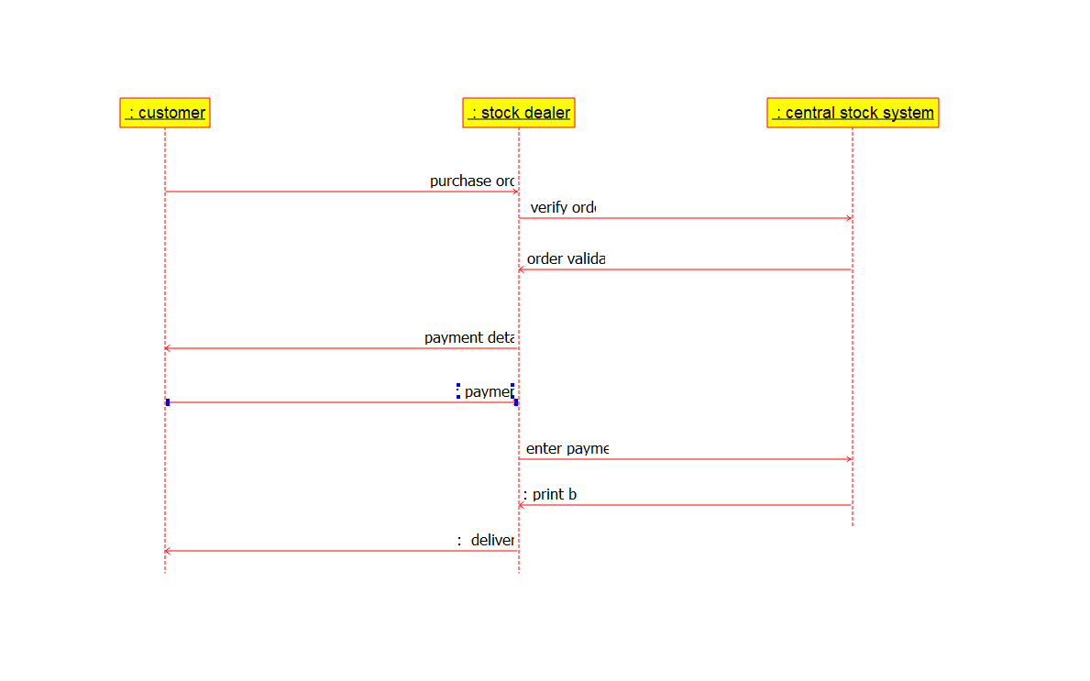
4)DEPLOYMENT DIGRAM:
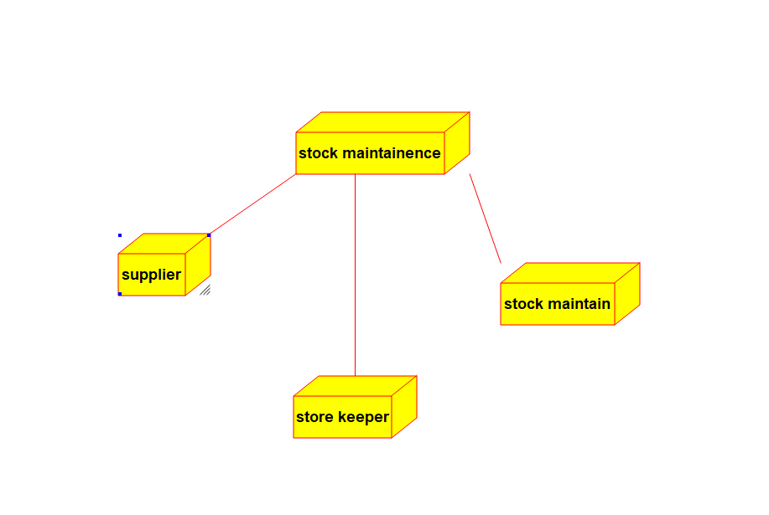

5)PACAKGE DIAGRAM:
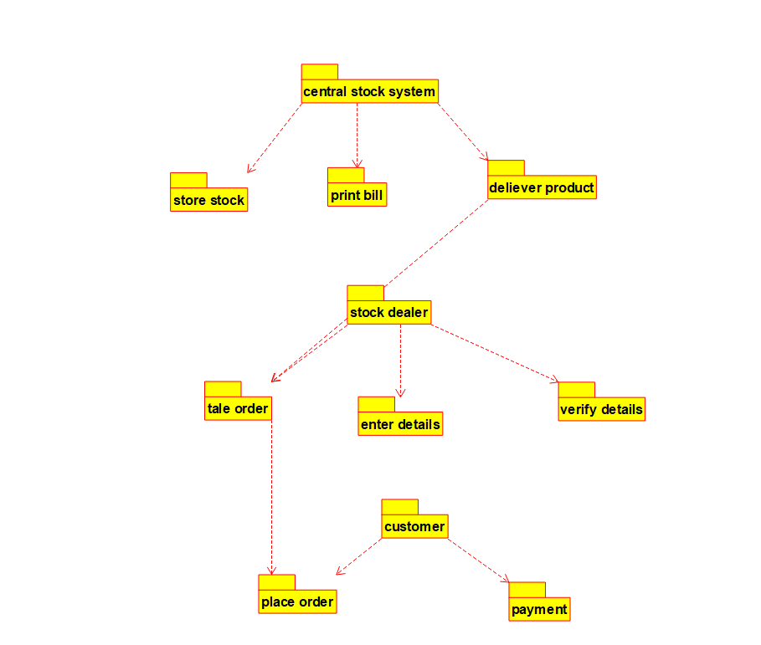
6)STATE DIAGARM:
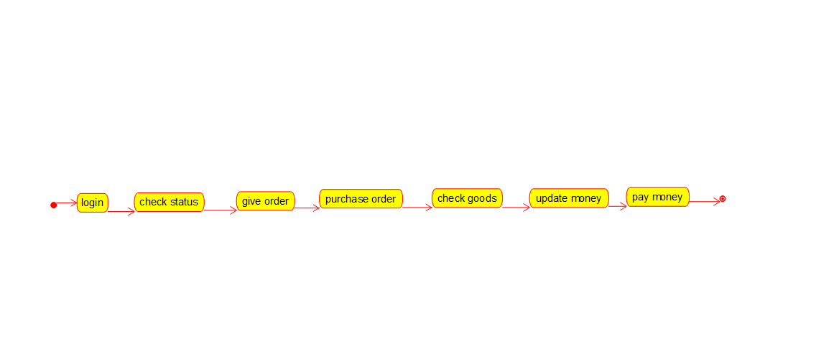

7)COMMUNICATION DIAGRAM:
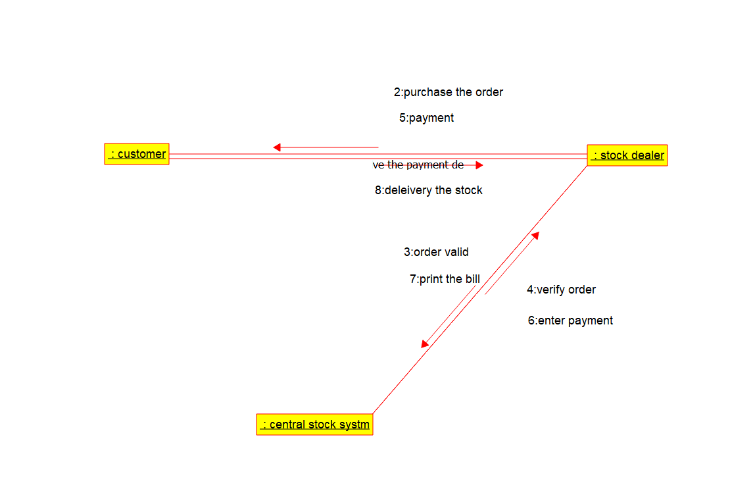
8)COMPONENT DIAGRAM:
